

Sleep Stage Classification from Physiological Heart-Related Signals Using Deep Learning

Under Supervision of:
DR. Ibrahiem Sadek
Eng. Veronica

Done By:
Nurhan Mohamed Reyad
Manar Hamdy

Abstract
Sleep stage classification is an essential task in biomedical signal processing, enabling automated analysis of physiological states during sleep. This study presents a complete pipeline for classifying sleep stages using heart-related biosignals derived from physiological recordings. The workflow includes signal preprocessing, annotation parsing, epoch segmentation, dataset balancing, normalization, and deep learning-based classification. A one-dimensional convolutional neural network (1D-CNN) is designed to extract temporal features from long sequential signals. The approach is motivated by both physiological relevance and the practical feasibility of using wearable devices for data acquisition.

1. Introduction
Heart-related physiological signals provide critical information about cardiovascular and autonomic nervous system activity. These signals are widely used in biomedical applications due to their strong correlation with physiological states such as sleep, stress, and physical activity.
A fundamental distinction exists between the electrocardiogram (ECG) and heart rate signals:
- ECG (Electrocardiogram): A raw, high-resolution electrical signal representing the full cardiac cycle, including P-wave, QRS complex, and T-wave.
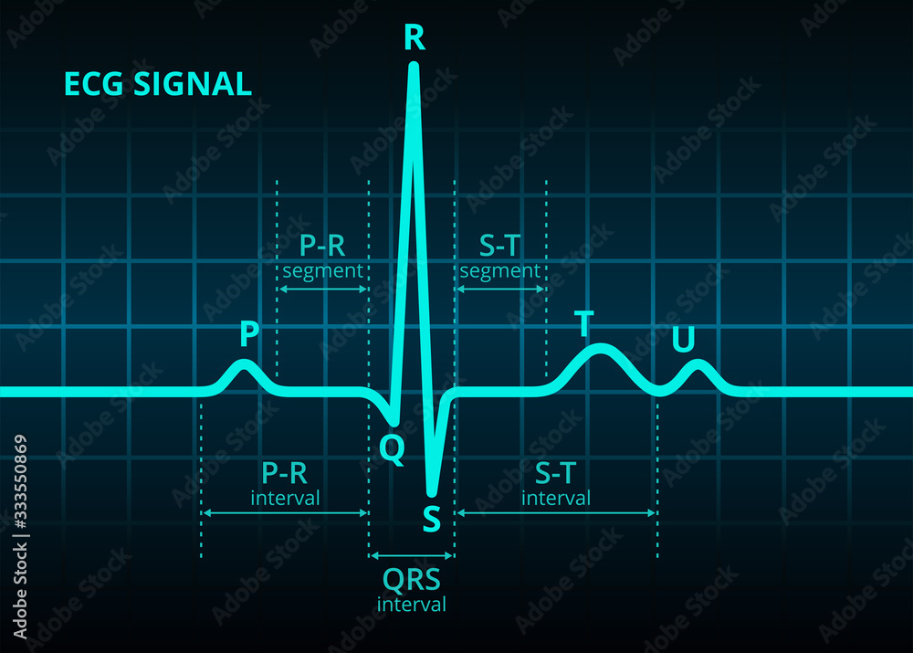

- Heart Rate (HR): A derived scalar representation computed from ECG by detecting R-peaks and calculativng beats per minute (BPM).
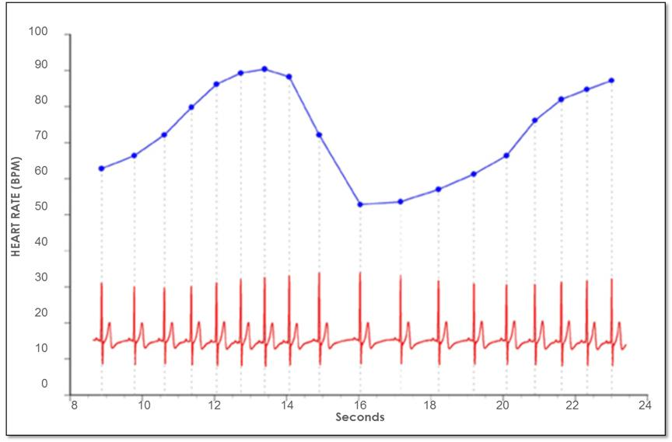

Key difference:
- ECG = full waveform (rich temporal + morphological information)
- HR = compressed physiological summary (low-dimensional representation)
The selection of heart-related signals in this work is driven by both physiological relevance and real-world deployment feasibility.

Why Heart Rate is Used
- Strong correlation with sleep stage transitions
- Reflects autonomic nervous system regulation
- Computationally efficient compared to raw ECG processing

Practical Motivation (Critical Design Choice)
- Does NOT require clinical-grade ECG setups
- Can be captured using wearable devices (smartwatches, fitness bands)
- Enables continuous, real-world, non-invasive monitoring

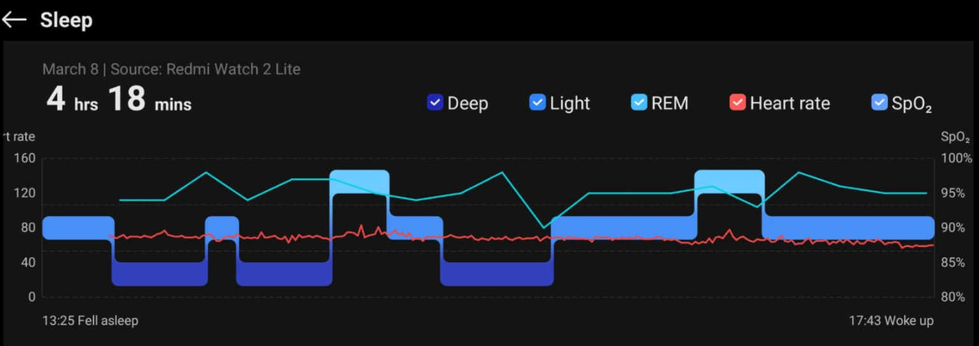

2. Materials and Methods

2.1 Data Acquisition (Code Implementation)
The dataset is structured into two main components:
- Signal files: EDF format stored in signals/
- Annotation files: XML format stored in annotations/
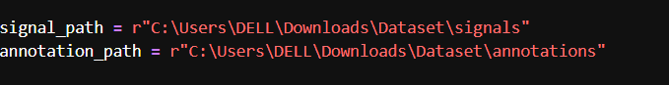signal_files = sorted(os.listdir(signal_path))
annotation_files = sorted(os.listdir(annotation_path))
- Sorting ensures correct pairing between signals and annotations
- Prevents misalignment between EEG/physiological data and labels

2.2 Annotation Parsing (XML Processing)
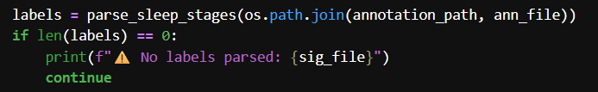
Sleep stage labels are extracted using structured XML parsingFiltering
logic:
Only sleep-related events are retained:
- Wake
- N1 (Stage 1)
- N2 (Stage 2)
- N3 (Stage 3)
- REM

Important note:
- Non-sleep events are discarded to reduce label noise

2.3 Epoch Segmentation
Signals are segmented into fixed windows:
- Epoch length = 30 seconds
This produces supervised samples aligned with annotations.

2.4 Dataset Construction (Final Extracted Data)
After preprocessing and segmentation:
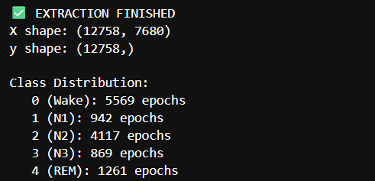

_Saving model:
We saved the model to use it later in other cells and for other trainings

2.5 Feature Conversion
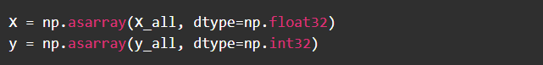
_ 12758 (number of samples / epochs)
This is the total number of extracted segments from the raw signals.
Each sample corresponds to a 30-second epoch of physiological data aligned with a sleep stage label.
_ 7680 (time steps per sample)
This represents the length of each signal segment.
It is determined by:
- Sampling frequency × epoch duration
- In your case:
7680 samples = 30 seconds × sampling rate (~256 Hz)
This means each epoch contains a continuous time-series signal of fixed length.
_ 1 (channel dimension “Heart rate”)

2.6 Normalization
Applied standardization:
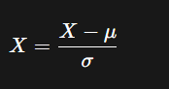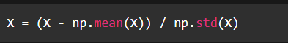
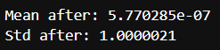

_Signal after normalization
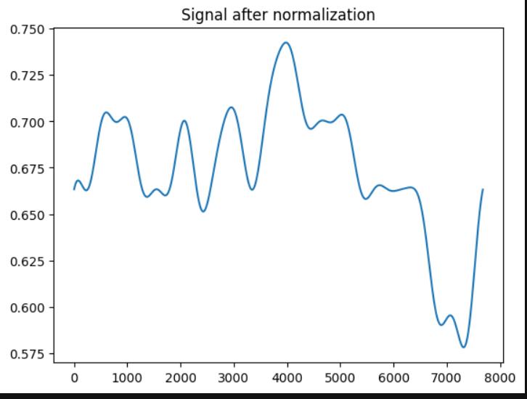

Purpose:
- Stabilizes gradient descent
- Removes amplitude bias between subjects

2.7 Train / Validation / Test Split
Stratified splitting ensures class balance preservation:
- Train: 70%
- Validation: 15%
- Test: 15%
Code:
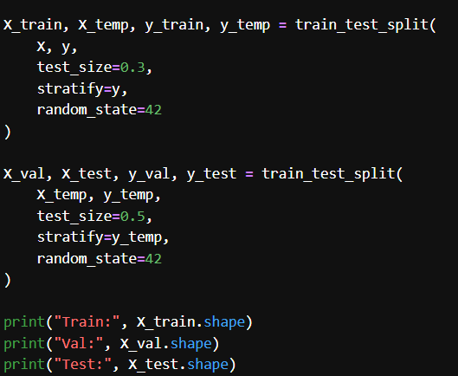

Resulting importance:
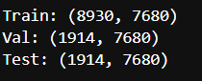

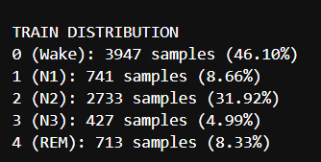
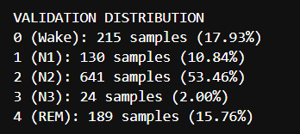
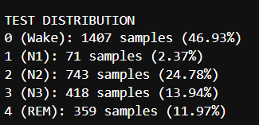
Due to imbalance, resampling is applied:
- Majority class: undersampling
- Minority classes: oversampling
Final balanced dataset:
- Each class = 5,569 samples
- Total = 27,845 samples
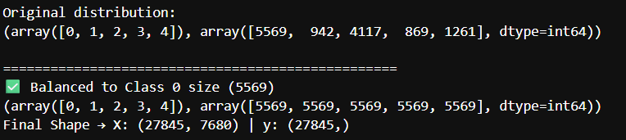

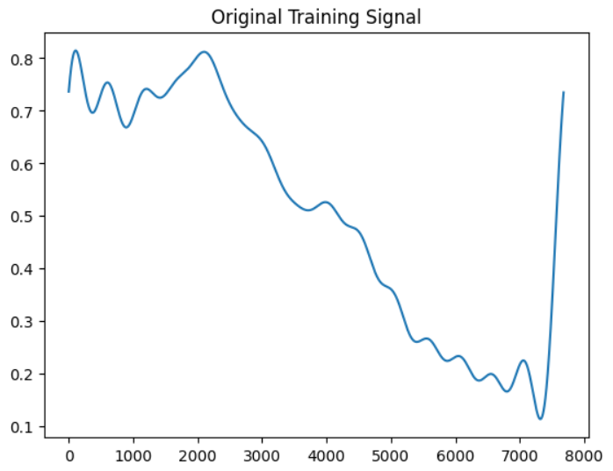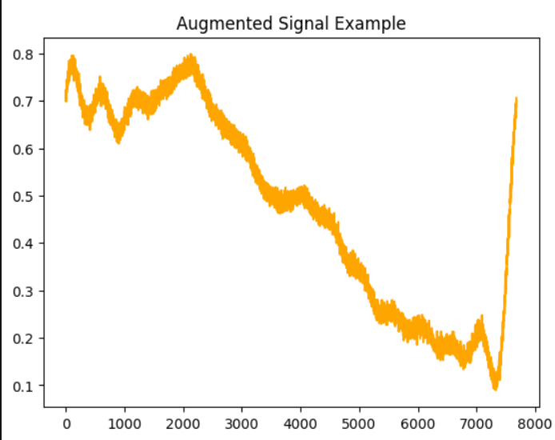

We used the augmentation in a specific models, not the last one, we used class weights in the model instead.

2.8 Data Storage (Reproducibility)
Data saved using NumPy binary format:
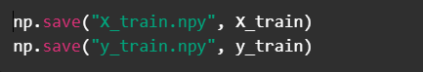
Purpose:
- Eliminates repeated preprocessing
- Ensures reproducibility of experiments

3. Model
We used a lot of models,
- Sometimes using balanced data by equalition and this gives us very low accuracy”About 50 in test accuracy”
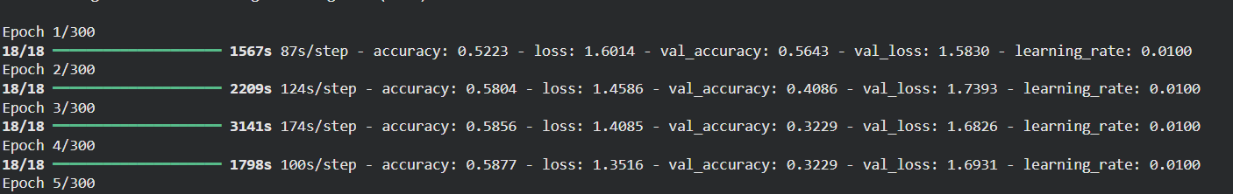
- We addad alotof layers for a model and gives us vey low accuracy too and estimated hours per epoch
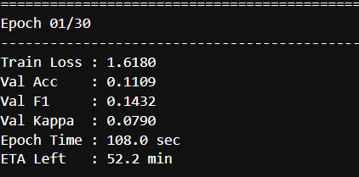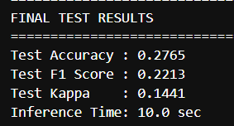

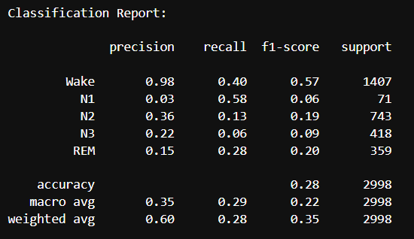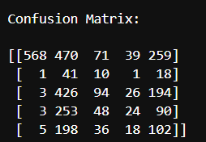
This model was according to this paper: https://doi.org/10.1016/j.engappai.2025.112562
- The third model we used is this:
deep learning pipeline Model developed for sleep stage classification using sequential physiological feature representations. Unlike the previous approach based on raw signal learning, this model uses manually extracted statistical and temporal features derived from heart-related signals.
The workflow consists of:
- Feature extraction
- Sequential window generation
- Dataset normalization
- Class imbalance handling
- Bidirectional recurrent neural network training
- Performance evaluation

  - Libraries and Their Functions
_NumPy
_TensorFlow / Keras
Used for:
- Building recurrent neural networks
- Training and optimization
- Mixed precision acceleration
- Callback implementation
_Scikit-learn
Used for:
- Dataset splitting
- Classification metrics
- Confusion matrix generation
_ Seaborn
Used for:
- Confusion matrix visualization

_Matplotlib
Used for:
- Plotting training curves
- Accuracy/loss visualization

3.3 Feature Extraction Stage
Purpose
Instead of directly feeding raw physiological signals into a convolutional neural network (CNN), the proposed approach first extracts handcrafted statistical and temporal features from each signal segment. These extracted descriptors are then provided as sequential inputs to a Bidirectional Gated Recurrent Unit (BiGRU) network, which is designed to learn temporal dependencies across consecutive feature sequences. This strategy reduces input dimensionality while preserving essential physiological information related to sleep stage transitions.
3.4 Extracted Features
1. Mean
mean = np.mean(x)
Purpose:
- Measures average signal amplitude
- Represents baseline physiological level
2. Standard Deviation
std = np.std(x)
Purpose:
- Measures variability of the signal
- Indicates fluctuations in heart activity
3. Range
rng = np.max(x) - np.min(x)
Purpose:
- Captures signal amplitude spread
- Reflects physiological variation
4. RMSSD (Root Mean Square of Successive Differences)
rmssd = np.sqrt(np.mean(diff**2))
Purpose:
- Measures short-term variability
- Widely used in heart rate variability (HRV) analysis
- Strong indicator of autonomic nervous system activity
5. MAD (Mean Absolute Difference)
mad = np.mean(np.abs(diff))
Purpose:
- Measures average temporal change
- Captures signal dynamics
6. Energy
energy = np.mean(x**2)
Purpose:
- Measures signal power/intensity
- Indicates overall activity magnitude
7. Skewness
skew = np.mean((x - mean)**3) / (std**3 + 1e-8)
Purpose:
- Measures asymmetry of signal distribution
- Detects abnormal distribution behavior
8. Slope
slope = (x[-1] - x[0])
Purpose:
- Captures overall signal trend
- Detects increasing or decreasing behavior

3.9 Class Imbalance Handling
Problem
Sleep datasets are naturally imbalanced.
Example:
- Wake and N2 dominate
- N1 and N3 are underrepresented
We changed the class weights alo
And this affected on the last accuracy, F1, pecisions, Recall,…etc
  - 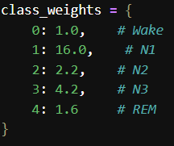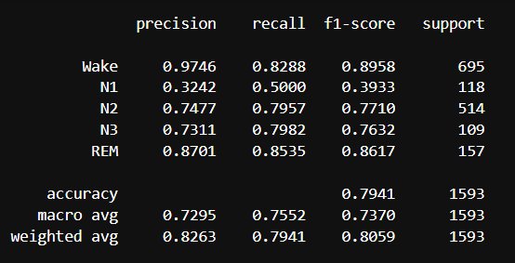
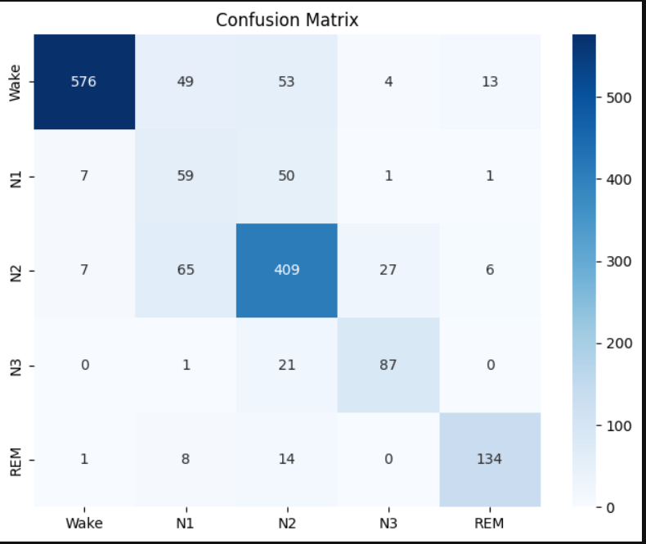

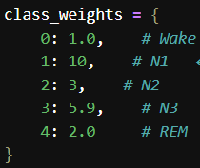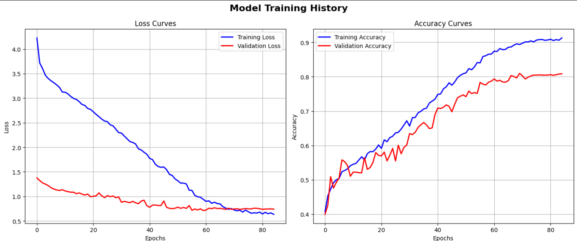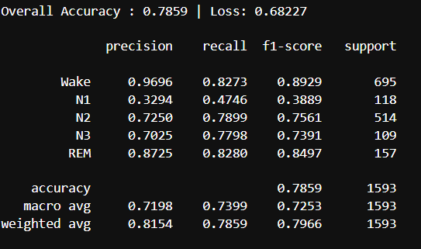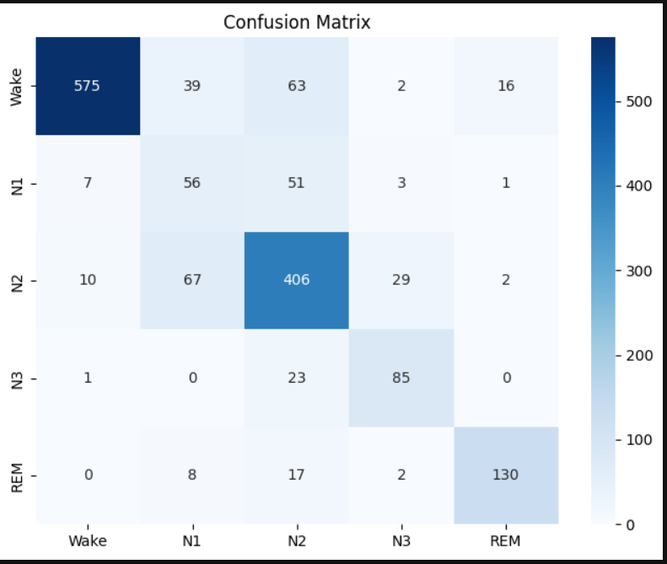

  - Best model
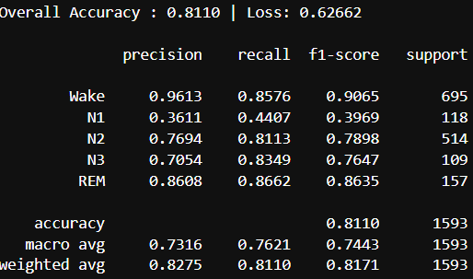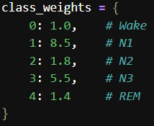

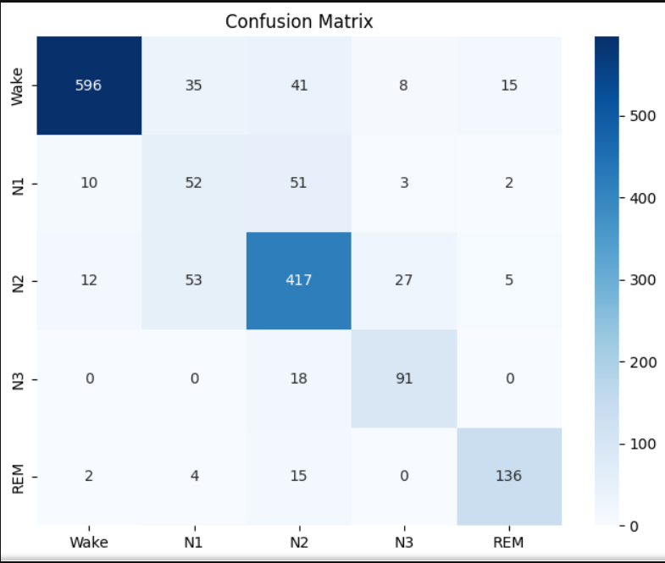

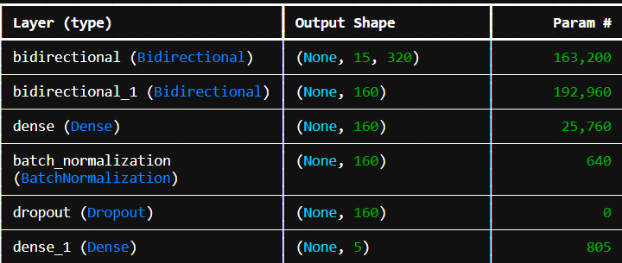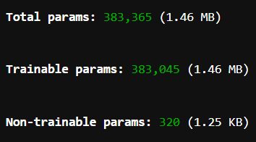

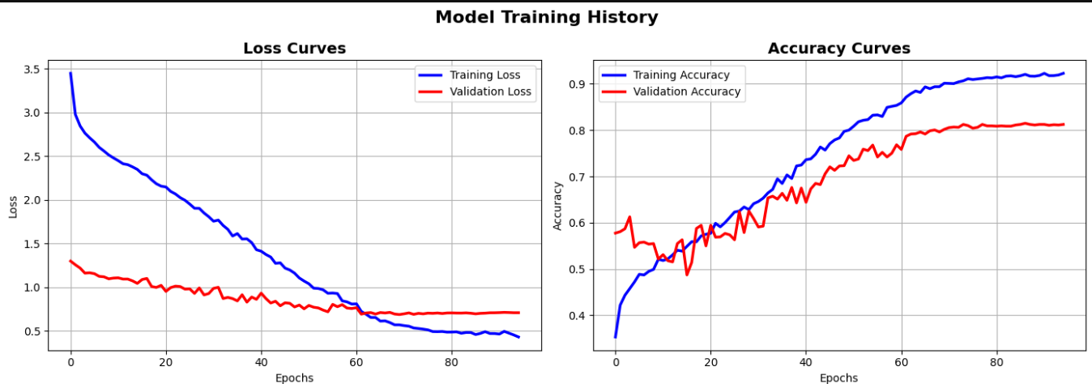

3.5 Mixed Precision Training
tf.keras.mixed_precision.set_global_policy('mixed_float16')
Purpose:
- Faster GPU computation
- Reduced memory usage
- Improved training efficiency

3.6 Model Architecture
Input Layer
Input(shape=(SEQ_LEN, X_train.shape[2]))
Input shape:
(15, 8)

3.7 Bidirectional GRU Layers
First GRU Layer
Bidirectional(GRU(160, return_sequences=True))
Purpose:
- Learns temporal dependencies
- Processes sequences forward and backward
Why Bidirectional?
- Sleep stages depend on both past and future context
Second GRU Layer
Bidirectional(GRU(80, return_sequences=False))
Purpose:
- Compresses temporal information
- Produces final sequence representation
3.8 Dense Classification Layers
Dense(160, activation='relu')
Purpose:
- Learns nonlinear feature interactions
- Improves discriminative capability
3.9 Batch Normalization
BatchNormalization()
Purpose:
- Stabilizes training
- Accelerates convergence

3.10 Dropout Regularization
Dropout(0.32)
Purpose:
- Prevents overfitting
- Randomly disables neurons during training
3.11 Output Layer
Dense(5, activation='softmax')
Meaning:
- 5 output neurons
- One neuron per sleep stage:
  - Wake
  - N1
  - N2
  - N3
  - REM

3.12 Optimizer Configuration
Adam Optimizer
Adam(learning_rate=0.0015, clipnorm=1.0)
Why Adam?
- Adaptive learning
- Efficient convergence
Gradient Clipping
clipnorm=1.0
Purpose:
- Prevents exploding gradients
- Stabilizes recurrent training

3.13 Loss Function
loss='sparse_categorical_crossentropy'
Purpose:
- Multi-class classification loss
- Efficient integer label handling

3.14 Training Strategy
Epochs
epochs=150
Maximum training iterations.
Batch Size
batch_size=512
Large batch training:
- Faster GPU utilization
- Stable gradient updates

3.15 Training Callbacks
Early Stopping
EarlyStopping(...)
Purpose:
Stops training when validation loss stops improving

ReduceLROnPlateau
ReduceLROnPlateau(...)
Purpose:
- Reduces learning rate automatically
- Helps fine convergence

  - Code of last one
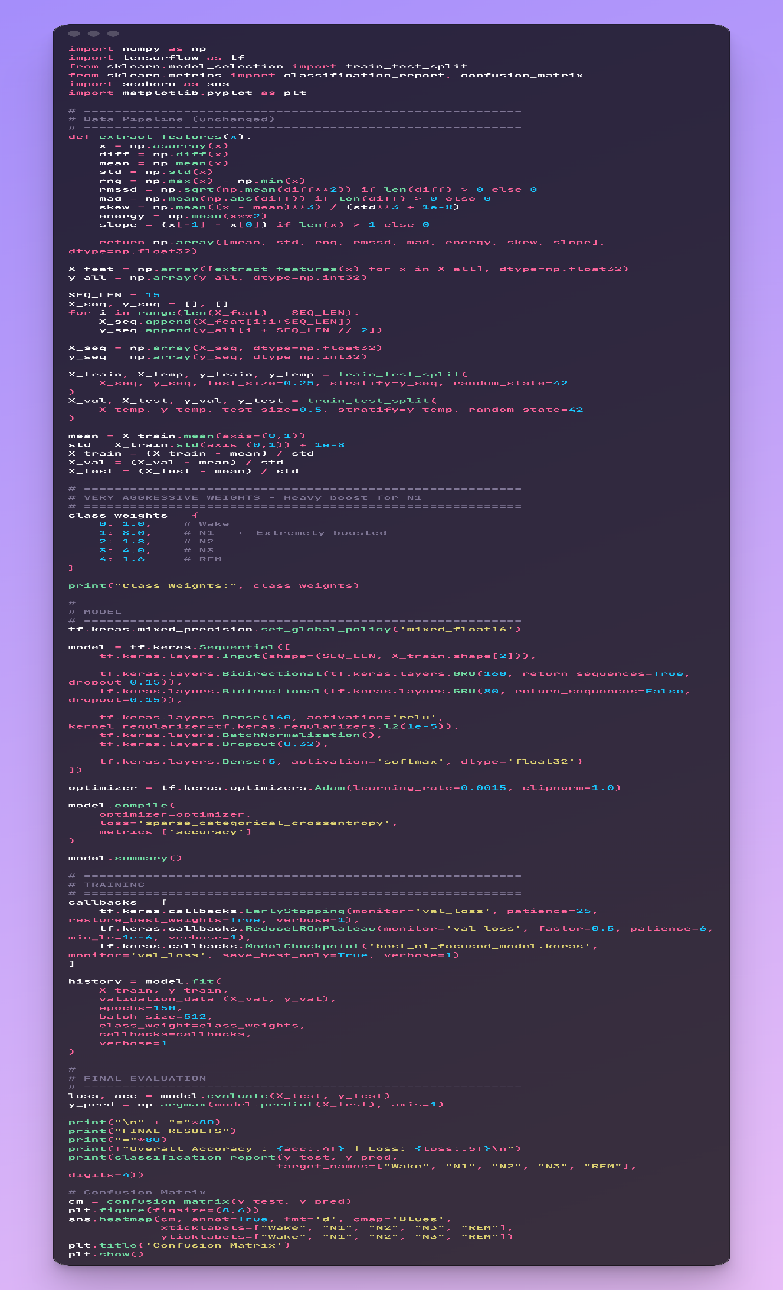


Conclusion
This study presented an end-to-end machine learning pipeline for sleep stage classification using heart-related physiological signals. The complete workflow included signal preprocessing, annotation parsing, epoch segmentation, normalization, dataset balancing, and feature preparation, followed by the development and evaluation of deep learning models for automatic classification of sleep stages.
The use of heart-related signals was motivated by their strong physiological connection to autonomic nervous system activity during sleep, as well as their practical advantages in real-world applications. In particular, such signals can be acquired using wearable devices, making the proposed approach suitable for continuous and non-invasive sleep monitoring outside clinical environments.
The experimental pipeline demonstrated that transforming raw biosignals into structured representations and balanced datasets significantly improves learning stability and model performance. The application of deep neural architectures allowed the model to capture temporal dependencies within physiological patterns associated with different sleep stages.
Overall, the results confirm that heart-related biosignals contain sufficient discriminative information for sleep stage classification and support their use as a viable alternative or complement to traditional polysomnography systems in wearable health technologies.

Gith Hub link:
https://github.com/NurhanGhonim/sleep-stage-classification.git

